SUMMERVILLE CREDIT UNION · BUSINESS BANKING USER GUIDE · CSUM-09 of 16
Recipient Management
Module: Business Banking > Payments > Recipient Management
Navigation: Dashboard → Business Banking → Recipient Management
Sources: Summerville Reports Series A + Series B | Features: nFinia Documentation Features Spreadsheet
01 PRODUCT SUMMARY

Transfer Account Management (Recipient Management) provides a centralized directory of all saved external accounts used for ACH and wire transfers. The interface displays recipients as color-coded cards with the recipient name, account type, and status. Users can search, filter, add new transfer accounts, and view or edit existing account details.
The feature supports multiple account types including external bank accounts for ACH transfers and wire beneficiary accounts. Each recipient record stores the account holder name, routing number, account number, and account type. The management interface also provides a link to copy transfer accounts from other sources.
For credit unions, recipient management reduces errors in payment processing by maintaining a validated directory of external accounts. It also reduces onboarding friction — once a business sets up their vendor and payee accounts, executing payments becomes a simple selection rather than manual data entry.
At a Glance
Attribute | Detail
Feature Name | Recipient Management
Module | Business Banking > Payments > Recipient Management
Navigation | Dashboard → Business Banking → Recipient Management
User Roles | Business Owner, Authorized Signer, Business Admin
Access Level | Role-based; requires Recipient Management permission
Key Actions | View recipients, Add new account, Edit account, Delete account, Search
Regulatory Relevance | BSA/AML recipient verification, OFAC screening

02 KEY USE CASES

Use Case | Who Uses It | What They Do | Business Value
Add Vendor Account | Business Owner | Add new external bank account for vendor payments | Pre-validates account details to prevent payment errors
Review Recipient Directory | Authorized Signer | Browse saved accounts before initiating transfer | Quick lookup of verified payment destinations
Edit Account Details | Business Admin | Update routing or account number for existing recipient | Maintains accurate payment information
Remove Inactive Recipient | Business Owner | Delete accounts for vendors no longer in use | Keeps directory clean and reduces selection errors

03 STEP-BY-STEP USER GUIDE

How to get here: Dashboard → Business Banking → Recipient Management
Step 1: Log In and Open the Dashboard
Open your web browser and navigate to the Summerville Credit Union digital banking platform. Enter your username and password on the login screen and click "Log In." If prompted, complete the OTP (One-Time Passcode) verification by entering the code sent to your registered device. After successful authentication, you will land on the Dashboard — also called the Account Overview screen. This is your home base. The Dashboard displays all your business accounts (Savings Accounts, Checking Accounts) with their available and current balances. The top navigation bar shows links to Dashboard, Accounts, Transfer & Pay, Cards, Business Banking, and More. On the right sidebar you will see Related Links (Change Password, Account Settings, View Scheduled Transfers, Account Specific Alerts) and a Quick Transfer widget for fast internal transfers. To proceed to Business Banking features, locate the "Business Banking" tab in the top navigation bar and click on it.
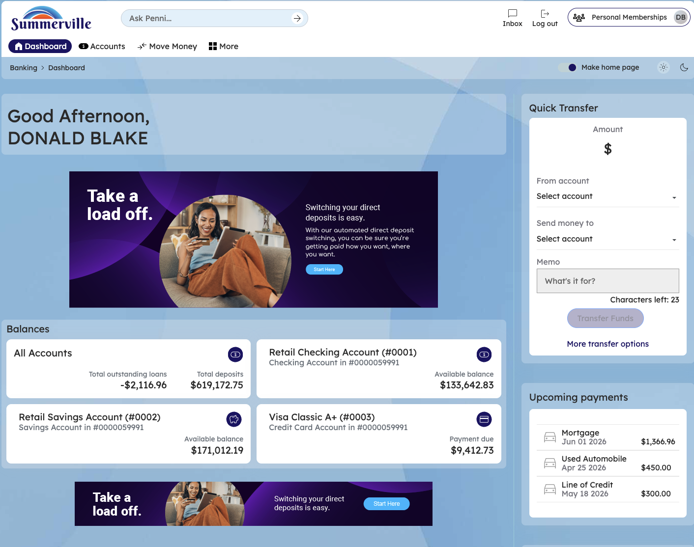
Figure 1 — Log In and Open the Dashboard

Step 2: Open the Business Banking Hub
After clicking "Business Banking" in the top navigation bar, the Business Banking Hub loads. This is the central command center for all commercial banking operations. The Hub is organized into three sections: "Transfers" at the top (with tiles for ACH Transfer, Domestic Wire Transfer, Transfer Template, and Payment From File), "Manage" in the middle (with tiles for Role Management, User Management, Approval Settings, and Recipient Management), and "More Options" at the bottom (with tiles for Commercial Activity, Reports, and Approvals). Each tile is a direct entry point to its corresponding feature. Only tiles your role has permission to access will be visible. From here, locate and click the tile for the feature you need — the next steps will guide you through the specific workflow.
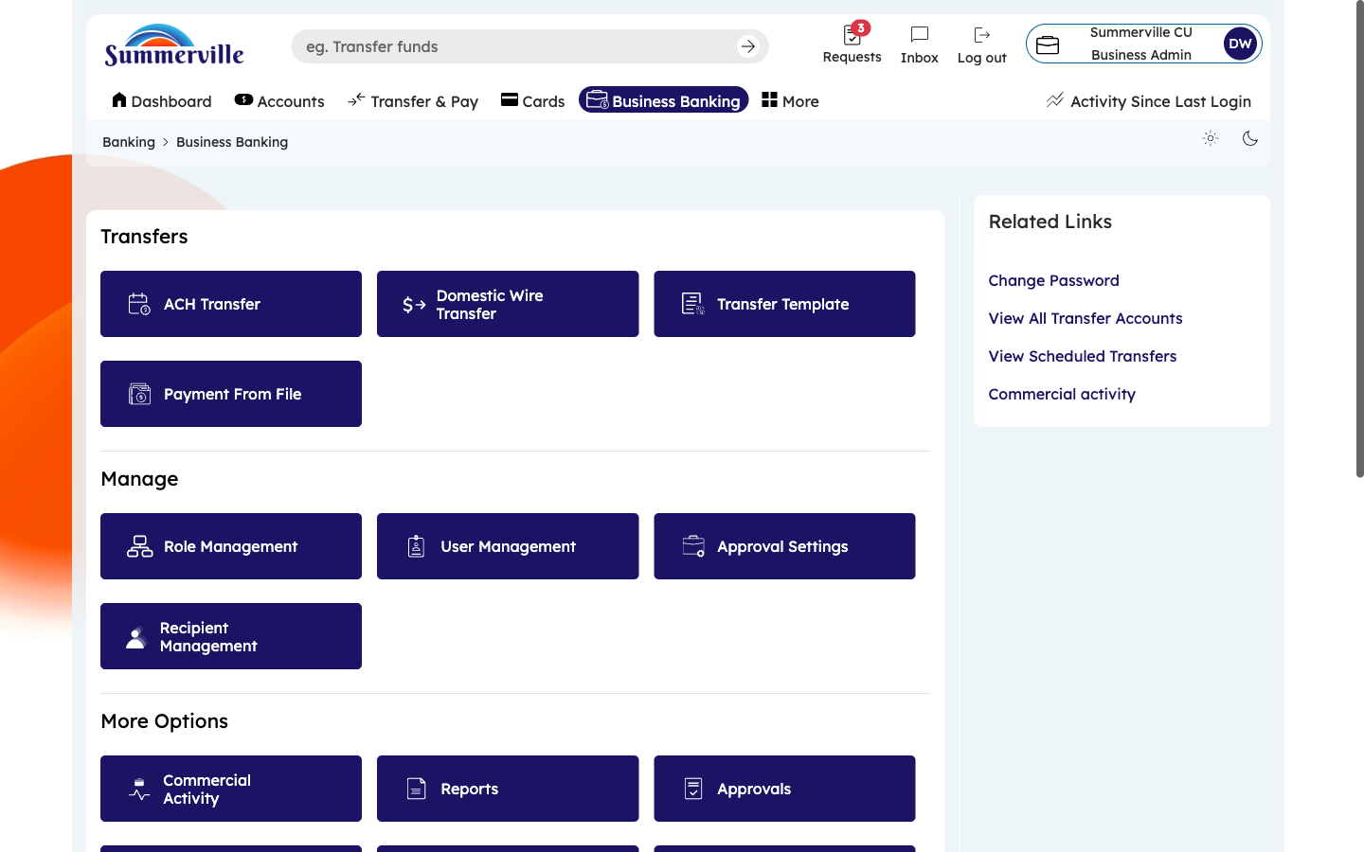
Figure 2 — Open the Business Banking Hub

Step 3: Navigate to Recipient Management
From the Dashboard, click "Business Banking" in the left-side navigation menu to open the Business Banking Hub. In the "Manage" section, click the "Recipient Management" tile. The Transfer Account Management page appears, displaying all saved external accounts as color-coded cards in a grid layout. Each card shows the recipient name and account type. Use the search bar at the top to filter by recipient name. To add a new external account, click "Add Transfer Account." To import accounts from another source, click "Copy Transfer Account." The total number of saved accounts is shown on the page. Click any card to view or edit that recipient's details.
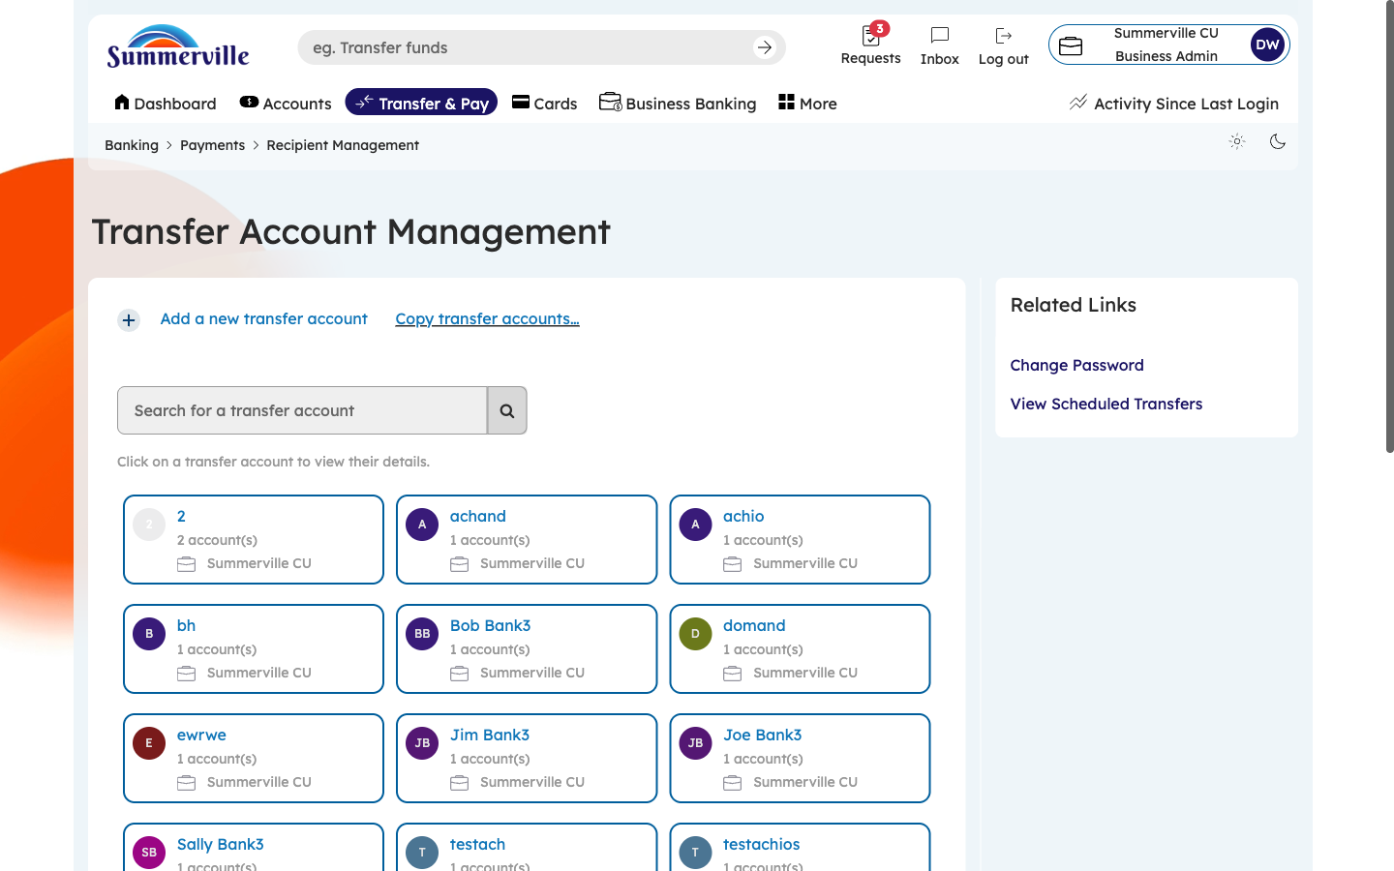
Figure 3 — Navigate to Recipient Management

Step 4: View and Edit Recipient Details
Click on any recipient card to open the full account detail view. This expanded display shows: Account Holder Name (the legal name on the recipient's bank account), Routing/ABA Number (the 9-digit bank routing number), Account Number (masked for security — click to reveal if needed), and Account Type (Checking or Savings). For wire transfer accounts, additional fields show the beneficiary bank name, bank address, and intermediary bank details. To edit any field, click the "Edit" button and update the information. To delete this recipient entirely, click "Delete." Always verify routing and account numbers carefully, as incorrect details will cause payment failures. Click "Back" to return to the recipient directory.
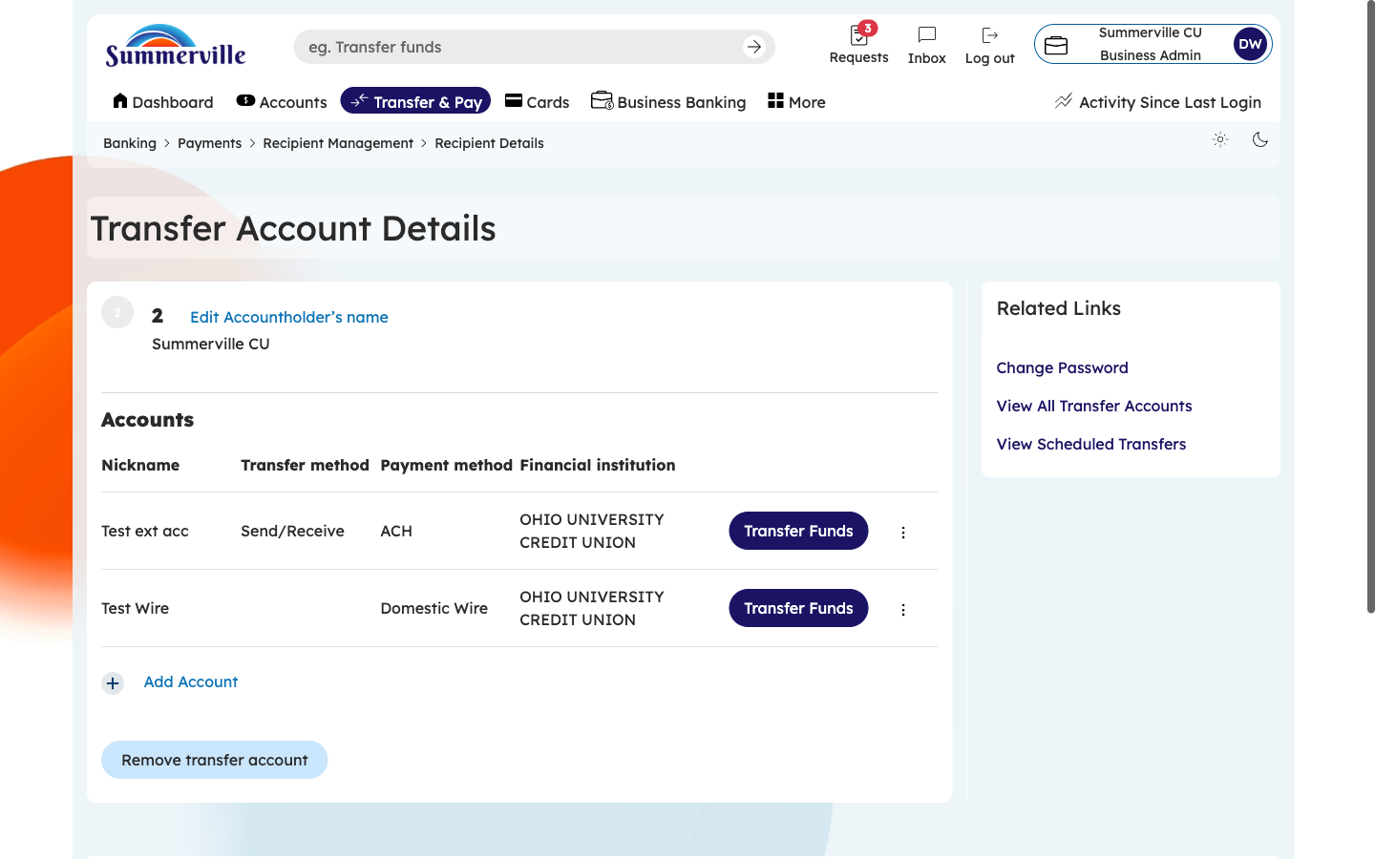
Figure 4 — View and Edit Recipient Details

